SMD

Software Development Management

## Module 1

### 29/05/2025

Analyze, design and implement high quality software projects

### **🔍 Overview**

This subject dives into **project management principles** and **modern software development practices**, with a strong emphasis on the **management side of software projects**.

### **🎯 Learning Outcomes**

By the end, you’ll be able to:

* **Critically apply** project management principles.
* Choose the **best development methodology** for different scenarios.
* **Manage risks** effectively, especially within multi-disciplinary teams.
* Estimate **effort, cost, and scheduling** like a pro.
* Design communication plans to boost **team collaboration**.
* Lead and coordinate teams with real-world strategies.

### **📅 Assessment Summary (12-week mode)**

| **Week** | **Task** | **Type** | **Weight** |
| --- | --- | --- | --- |
|  |  |  |  |
| 4 | 📄 **Project Proposal & Implementation Plan** | Group Report (8–10 pages + 500-word contribution) | 20% |
| 7 | 📝 **Requirements & Prototype** | SRS (12–15 pages) + GUI prototype + 500-word contribution | 30% |
| 10 | ✅ **Test Plan** | Report (3–5 pages + 500-word contribution) | 15% |
| 12 | 🚀 **Final Demo** | 15-min Demo + 750-word reflection | 25% + 10% |

All assignments are **group-based**, with individual contribution reports—so teamwork and communication are crucial.

### **🛠️ Requirements**

* No prerequisites ✅
* You **do need a computer/laptop** with relevant software

### **📚 Textbooks**

* No prescribed textbook 👏
* Suggested readings will be listed on the **Torrens library page** or the **subject portal**

### **💡 Pro Tips**

* Start forming your **group early**—collaboration is central here.
* Take the **individual contribution** seriously; it shows your personal value.
* Your final demo isn’t just a “show and tell”—it’s a **leadership test**. Show how your team worked together and what challenges you overcame.

### **📘 Chapter 1 Summary: An Overview of Project Management**

This chapter introduces the foundational concepts of project management. It defines key terms such as *project*, *project management*, and *project manager*, setting the stage for deeper exploration in later chapters. The author emphasizes the importance of understanding *why* projects fail, pointing to issues such as poor planning, unclear goals, lack of resources, and weak leadership.

The chapter outlines the **triple constraint**—*scope, time, and cost*—as the primary boundaries that every project must manage. It also introduces the **project life cycle**, which typically includes the phases of **initiation, planning, execution, monitoring/control, and closure**.

Additionally, it references the **PMBOK (Project Management Body of Knowledge)**, which standardizes the discipline by categorizing project management into **five process groups** and **ten knowledge areas**, ensuring consistency and professionalism in managing projects across industries.

The relationship between the PCTS constraints can be writ-

ten as follows:

C = f(P, T, S)

In words, this says, “Cost is a function of Performance, Time, and

Scope.” Graphically, I like to show it as a triangle, in which P, C,

and T are the sides and S is the area. This is shown in Figure 1-1

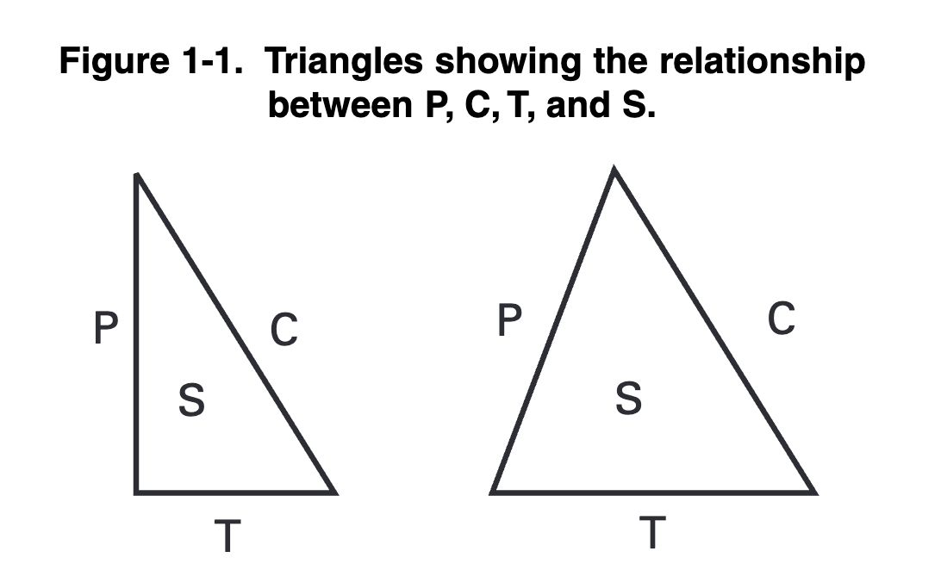

MLA 9th Edition (Modern Language Assoc.)

Lewis, James P. Fundamentals of Project Management. AMACOM, 2007.

APA 7th Edition (American Psychological Assoc.)

Lewis, J. P. (2007). Fundamentals of Project Management: Vol. 3rd ed. AMACOM.

Summary

Following are the key points that you should retain from this chapter.

÷ A project is a temporary endeavor undertaken to produce a unique product, service or result.

÷ A project is also a problem scheduled for solution.

÷ Project management is application of knowledge, skills, tools and techniques to project activities to meet project requirements. Project management is accomplished by applying the processes of initiating, planning, executing, monitoring and controlling, and closing.

÷ All projects are constrained by Performance, Time, Cost, and Scope requirements. Only three of these can have values assigned. The fourth must be determined by the project team.

÷ Projects tend to fail because the team does not take time to ensure that they have developed a proper definition of the problem being solved.

÷ The major phases of a project include concept, definition, planning, execution and control, and closeout.

MLA 9th Edition (Modern Language Assoc.)

Lewis, James P. Fundamentals of Project Management. AMACOM, 2007.

APA 7th Edition (American Psychological Assoc.)

Lewis, J. P. (2007). Fundamentals of Project Management: Vol. 3rd ed. AMACOM.

### 30/05/2025

### **🔍 Chapter 3 Summary – Key Takeaways**

**Title**: *Information Technology Project and Systems Life Cycles: Project Management and Team Activities*

**Author**: Taylor, J. (2003)

This chapter explores:

#### **🔁 1. Project Life Cycle vs. Development Life Cycle**

* **Project Life Cycle (PLC)**: Manages the *business side* — initiation to closure.
* **Development Life Cycle (SDLC)**: Manages the *technical side* — requirements to deployment.
* Taylor emphasizes that **blending both** cycles effectively is **crucial for IT projects**.

#### **🆚 2. IT Projects vs. Other Projects**

* IT projects are **more iterative**, involve **more uncertainty**, and often **evolve mid-execution**.
* They **require adaptive planning**, frequent validation, and **tight feedback loops** with stakeholders.

#### **🤝 3. Project Management & Team Roles**

* Project success heavily depends on **team dynamics**, **communication plans**, and **collaborative tools**.
* Strong focus on **role clarity**, **risk ownership**, and **cross-functional teamwork**.

### **🧠 How You Can Use This for Assessment 1**

Here’s how to **reference and embed** insights from Taylor’s chapter directly into your assessment:

| **Assessment Component** | **How Taylor Helps** |
| --- | --- |
| 🔧 **Development Lifecycle** | Justify your chosen SDLC (e.g., Agile vs. Waterfall) based on complexity & iteration needs |
| 🧭 **Project Lifecycle Stages** | Align your project plan milestones with PLC phases: Initiation → Planning → Execution → Closure |
| ⚠️ **Risk Management** | Emphasize uncertainty in IT projects and create adaptive mitigation strategies |
| 👥 **Team Allocation** | Reference Taylor’s emphasis on role clarity and collaborative dynamics for success |
| 📡 **Communication Plan** | Highlight the need for structured feedback cycles and stakeholder engagement routines |

Proper APA Reference (2020 format):

Taylor, J. (2003). *Chapter 3: Information technology project and systems life cycles: Project management and team activities*. In *Managing Information Technology Projects* (pp. 38–73). American Management Association International. https://search.ebscohost.com/login.aspx?direct=true&AuthType=shib&db=e000xww&AN=100162&site=ehost-live&custid=ns251549&ebv=EB&ppid=pp_38

### **📘 Chapter 1 Summary – Key Insights**

**Title**: *Introduction to Agile Project Management*

**Author**: Cobb, Charles G. (2015)

This chapter covers:

#### **🧠 1. History & Evolution**

* Traditional **Waterfall** approaches dominated early software development.
* Their linear nature made them unsuitable for projects with **changing requirements**.

#### **⚙️ 2. Waterfall vs. Agile**

* **Waterfall**: Sequential, rigid, prone to delays if initial requirements were wrong.
* **Agile**: Iterative, flexible, promotes **customer collaboration**, **incremental delivery**, and **continuous feedback**.

#### **🔄 3. Agile Mindset & Benefits**

* Agile isn’t just a methodology—it’s a **philosophy** rooted in adaptability and collaboration.
* Benefits include:  
  + Faster value delivery
  + Higher customer satisfaction
  + Better risk management
  + Stronger team ownership

#### **💼 4. Project Management Transformation**

* Agile shifts the role of project managers from **command-and-control** to **facilitator and enabler**.
* Emphasis on **self-organizing teams**, transparency, and stakeholder engagement

### **🎯 How to Use This in Assessment 1**

| **Assessment Section** | **How Cobb Helps** |
| --- | --- |
| 🌀 **Software Development Process** | Justify using Agile by contrasting it with Waterfall and tying it to project adaptability |
| 🤝 **Team Structure** | Explain how Agile empowers teams and encourages cross-functional collaboration |
| 🧱 **Risk Management** | Highlight how Agile reduces risk through early testing and stakeholder feedback |
| 📈 **Project Schedule** | Show how Agile delivers incremental value and adapts to changing requirements |

Proper APA Reference (2020 format):

Cobb, C. G. (2015). *The project manager’s guide to mastering agile: Principles and practices for an adaptive approach*. John Wiley & Sons. https://ebookcentral-proquest-com.torrens.idm.oclc.org/lib/think/detail.action?docID=1895876